Visit to the Brickworks Museum, (Bursledon Brickworks)

A listed Grade II site, purportedly the UK's sole surviving Victorian steam-driven brickworks telling a fascinating story about the history of bricks and the brickworks.

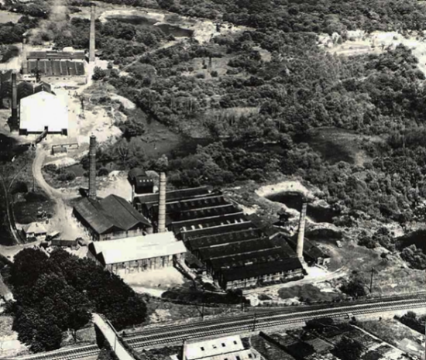
Summary

The tour takes approximately 1.5 to 2.0 hours, followed by the opportunity to wander round the rest of the museum at leisure. Approx charge £10.00 per person covering the admission fee, refreshments on arrival and guided tour. Opening times 11am-4pm -depart Brock by car / car share at 10.15am.

History

Founded in 1897 the brickworks was a partnership with a successful Southampton builder’s merchants. While the first brickyard was at Chandlers Ford the company jumped at the opportunity to start making bricks at Bursledon where there was abundant clay and very good rail and river links.

The clay was brought back to the factory using narrow gauge railway wagons. Latterly as the clay was worked out further and further away, it was brought to the works on an overhead cable system. By 1935 the site was one of the main producers of bricks in the region, producing more than 20 million bricks a year. In 1959 it became Redland Holdings Ltd.

The site closed in 1974 for a number of reasons, not least the New Health and Safety at Work Act. Since the works had not been updated during its working life this meant the new safety requirements would have been almost impossible to achieve, however it resulted in the preservation of rich industrial heritage.

Key Attractions

Discovery of brick making methods and an industrial heritage of equipment making the brickworks.

NB Dates are provisional and to be confirmed by the Brickworks

Queries to John Wingham

4 Jan 2023

